KUBERNETES DEPLOYMENT ASSIGNMENT
Submitted By: Siddharth Ravat
Technology Used: Docker, Kubernetes, Minikube, Flask, Express.js

1. Objective
The objective of this assignment is to deploy a full-stack application in a local Kubernetes cluster using Minikube.
The project consists of:
- Express Frontend running on port 3000
- Flask Backend running on port 5000
Both applications were containerized using Docker and deployed in Kubernetes using Deployments and Services.

2. Docker Images
The Docker images for both the frontend and backend applications were created successfully.
The following command was used:
docker images
The images used for Kubernetes deployment were:
- express-frontend:fixed
- flask-backend:latest
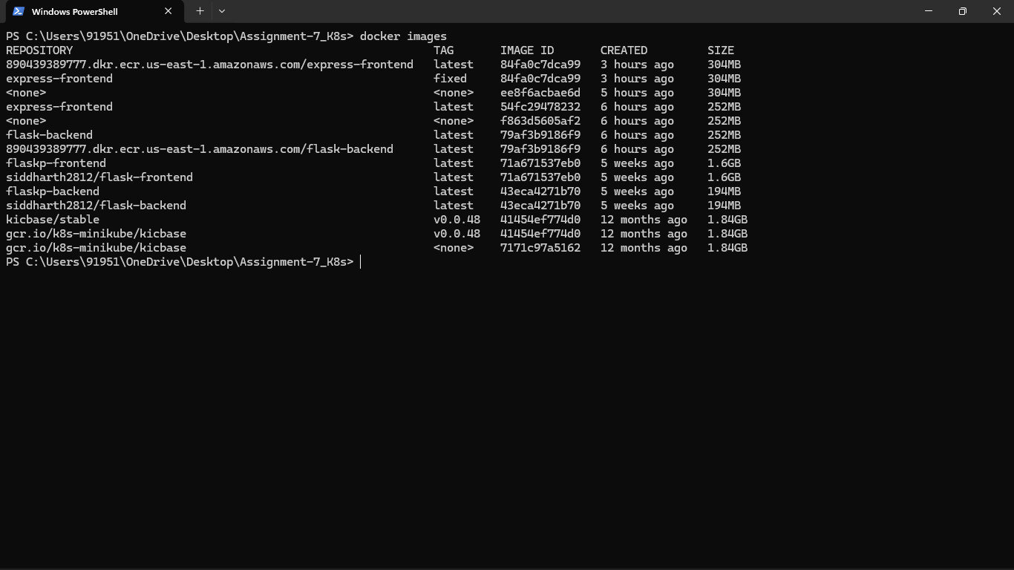

3. Starting the Minikube Cluster
Minikube was used to create and run a local Kubernetes cluster.
The cluster was started using the Docker driver with the following command:
minikube start --driver=docker --cpus=2 --memory=3000mb
The Minikube status was verified using:
minikube status
The Kubernetes components including the host, kubelet, and API server were successfully running.
Screenshot:
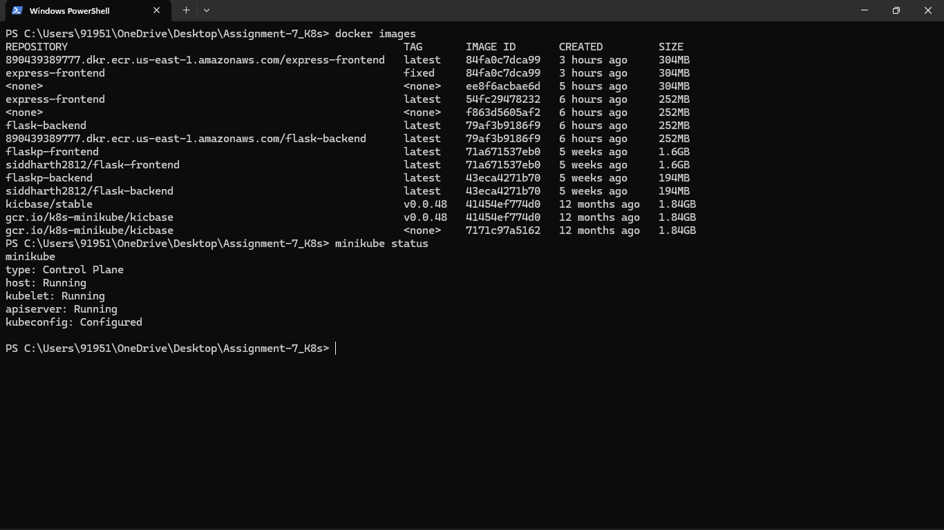

4. Kubernetes Configuration Files
A k8s folder was created to store the Kubernetes configuration files.
The following YAML files were created:
- backend-deployment.yaml
- backend-service.yaml
- frontend-deployment.yaml
- frontend-service.yaml
These files define the Deployments and Services required to run the frontend and backend applications inside Kubernetes.
Screenshot:
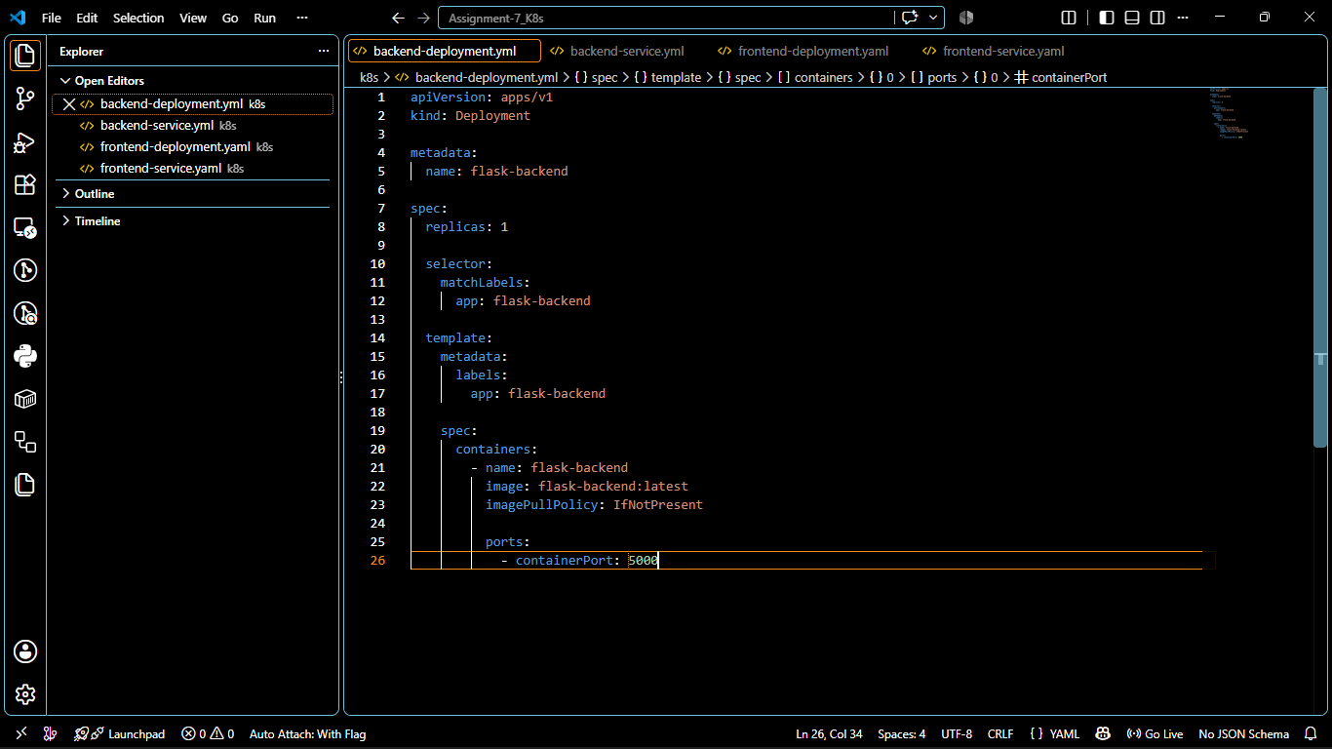

5. Backend Deployment
A Kubernetes Deployment was created for the Flask backend application.
Configuration used:
- Application: Flask Backend
- Docker Image: flask-backend:latest
- Container Port: 5000
- Replicas: 1
The Deployment manages the backend Pod and ensures that the required number of replicas is maintained.

6. Backend Service
A Kubernetes Service was created for the Flask backend.
The Service configuration used:
- Service Type: ClusterIP
- Port: 5000
- Target Port: 5000
The ClusterIP Service allows communication with the backend from within the Kubernetes cluster.

7. Frontend Deployment
A Kubernetes Deployment was created for the Express frontend application.
Configuration used:
- Application: Express Frontend
- Docker Image: express-frontend:fixed
- Container Port: 3000
- Replicas: 1
The Deployment manages the frontend Pod inside the Kubernetes cluster.

8. Frontend Service
A Kubernetes Service was created for the Express frontend.
The Service configuration used:
- Service Type: NodePort
- Port: 3000
- Target Port: 3000
The NodePort Service allows the frontend application to be accessed from outside the Kubernetes cluster.

9. Loading Docker Images into Minikube
The application Docker images were loaded into Minikube so that Kubernetes could use the locally created images.
The following commands were used:
minikube image load flask-backend:latest
minikube image load express-frontend:fixed
The images inside Minikube were verified using:
minikube image ls
Screenshot:
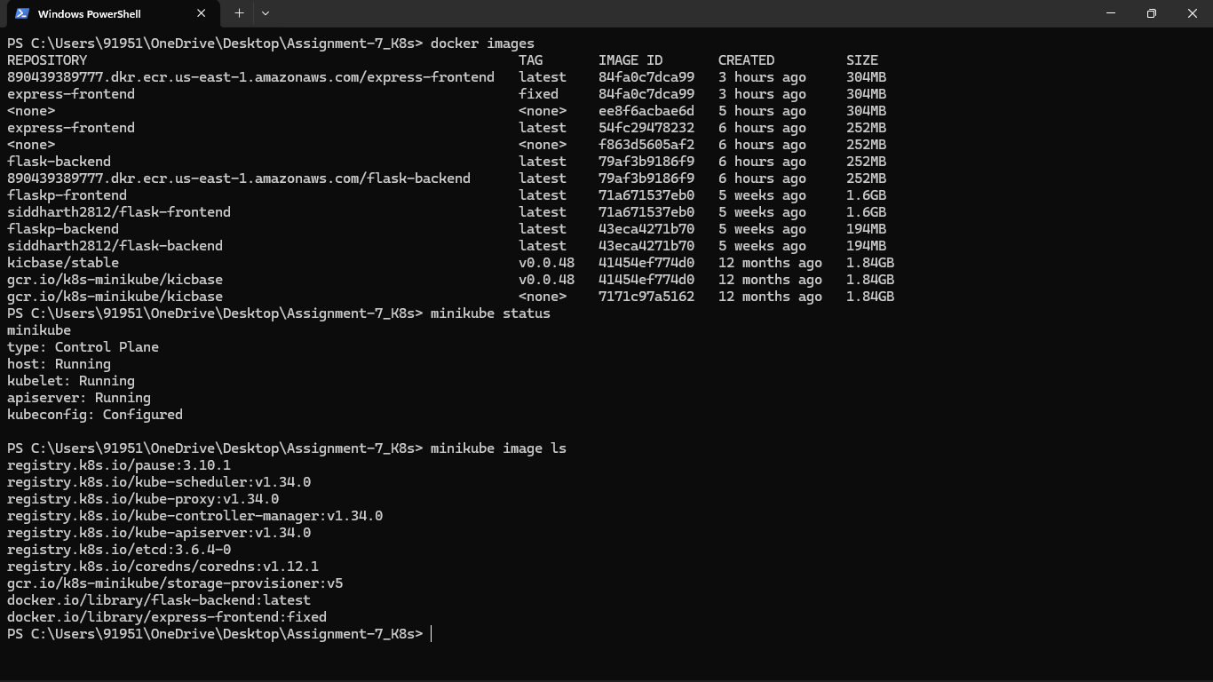

10. Deploying the Applications
The Kubernetes configuration files were deployed using:
kubectl apply -f k8s/
This command created the following resources:
- Flask Backend Deployment
- Flask Backend Service
- Express Frontend Deployment
- Express Frontend Service
Screenshot:
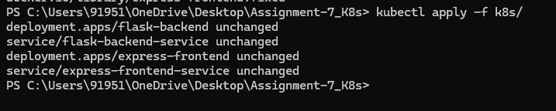

11. Verifying Kubernetes Pods
The running Pods were verified using:
kubectl get pods
Both the frontend and backend Pods were successfully running.
The output showed both Pods with the status:
1/1 Running
Screenshot:
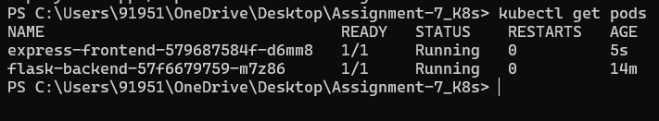

12. Verifying Kubernetes Services
The Kubernetes Services were verified using:
kubectl get services
The following Services were successfully running:
- express-frontend-service — NodePort
- flask-backend-service — ClusterIP
Screenshot:
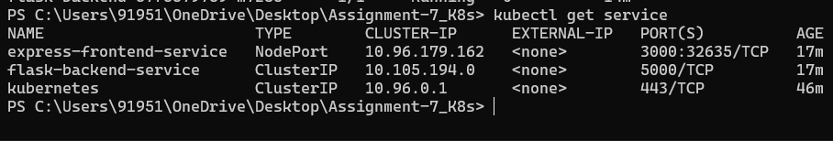

13. Accessing the Application
The frontend application was accessed using Minikube with the following command:
minikube service express-frontend-service
The application successfully opened in the browser.
The frontend was also successfully connected with the Flask backend, confirming successful communication between both applications inside the Kubernetes environment.
Screenshot:
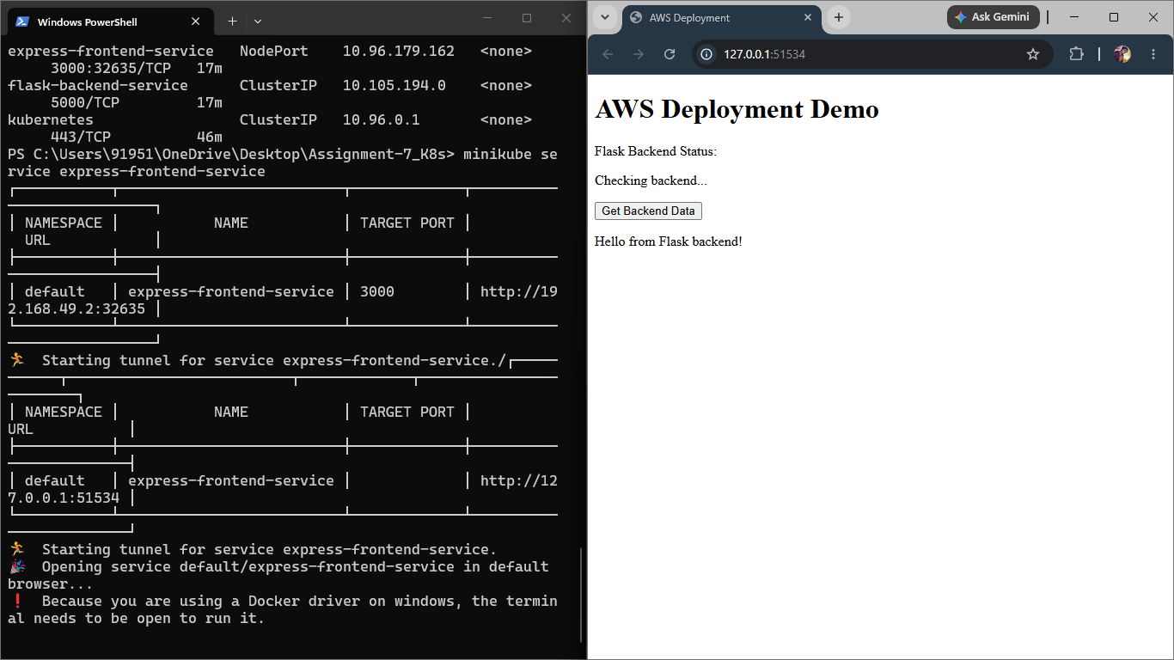

14. Verifying Kubernetes Deployments
The Kubernetes Deployments were verified using:
kubectl get deployment
Both deployments showed one desired and available replica.
The deployed applications were:
- Express Frontend
- Flask Backend
Both deployments were successfully available and running.
Screenshot:
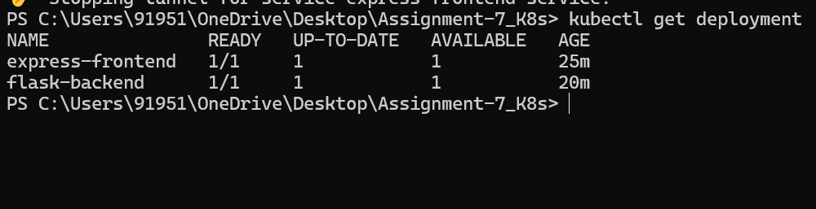

15. GitHub Repository
GitHub Repository Link:
PASTE YOUR GITHUB REPOSITORY LINK HERE

16. Conclusion
The full-stack application was successfully deployed on a local Kubernetes cluster using Minikube.
The Flask backend and Express frontend were deployed using Kubernetes Deployments and exposed using Kubernetes Services. The frontend was accessed through a NodePort Service, while the backend used a ClusterIP Service for internal communication.
Both Pods, Services, and Deployments were successfully verified, and the application was successfully accessed through Minikube.

